 GOHSEP Hurricane Preparation Worksheet
Current Storm | CAT- Winds | MB | Storm Surge | Storm Size | Worksheet Remarks (Direction, Speed, Summary)
H-120 (5 days)
H-96 (4 days)
H-72 (3 days)
H-48 (2 days)
H-24 (1 day)
H-12 hours
H-6 hours
Mb- Anything below 940 Mb is devastating, 940-965 Mb is really bad, below 980 requires close monitoring and over 1000 Mb is normal day to day thunderstorms.
Storm speed- Most storms move at about 8-10 mph, a storm moving above 10 mph is moving fast and below 5 mph has the potential to stall upon landfall.
Storm surge- Anything above 20’ is catastrophic and above 10’ is a major cause for concern.
Storm size- Use the I10 test. I10 is about 50 miles in straight line distance from the coast. So look at a storm size while it is over Cuba or in the Gulf, place the eye at the Louisiana coast and if the hurricane wind bands (not TS bands) pass I10, the storm (over 100 miles in circumference) it is likely to be a sustained major event.
Wind speed and Category- Winds are a critical indication of the violence of the storm. The higher the category/wind, the worse the internal storm effects will be.
Category and Wind Speed Range Information
Tropical Depression <39 MPH Tropical Storm 39-73 MPH CAT1 74-95 CAT2- 96-110 CAT3 111-130 CAT4- 131-155 CAT5- >155

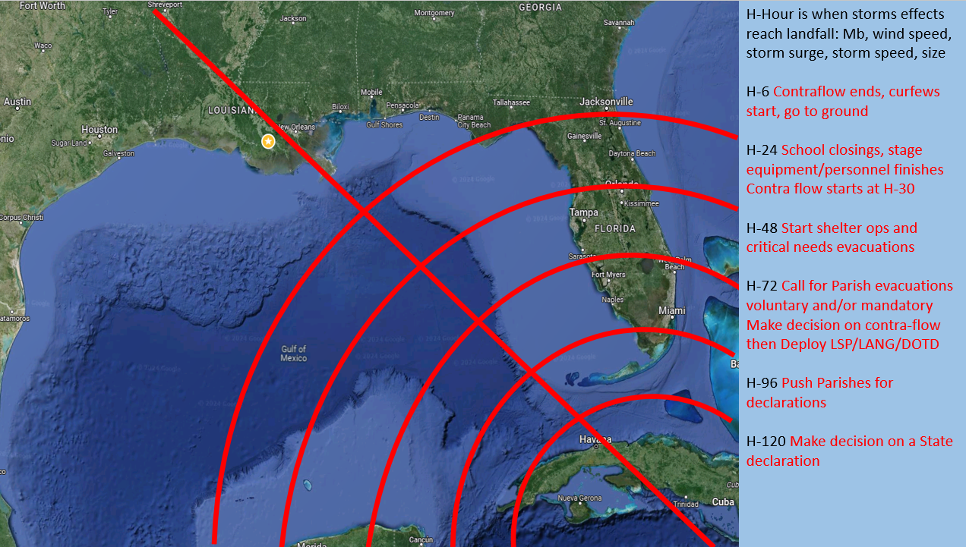
Hurricane Comparison Sheet
Name | Category- Winds | MB | Storm Surge | Damage Cost | Remarks- 30 Years of Major Storms in La.
Katrina- 2005 | 4-155 in La. | 935 | 28’ | $192B | 4th most intense US storm/16 ft storm surge increase in last 48 hours/Cat 4-150 miles
Rita- 2005 | 3-115 in La. | 937 | 12’ | $18.5B | Landfall 3 weeks after Katrina in Cameron/major wind damage/back to back storms
Gustav- 2008 | 2-110 in La. | 985 | 14’ | $8.3B | Landfall in Cocodrie/diagonal path across La/Cat 2-160 miles/1.5M without power
Ike- 2008 | 2-110 La. | 950 | 8’ | $38.1B | Landfall at the Tx-La line /Cat 2- 200 miles/major wind damage/back to back storms
Isaac- 2012 | 1-80 mph in La. | 975 | 11’ | $3.1B | Slow moving/Cat 1- 100 miles/made landfall twice-mouth of the river & Port Fourchon
Laura- 2020 | 4-150 mph in La. | 940 | 11’ | $16.2B | Landfall in Cameron/40 mb drop & 65 mph wind increase in last 24 hours/Cat 4-60 miles
 | CAT- Winds | MB | Storm Surge | Storm Size | Worksheet Remarks (Direction, Speed, Summary)
H-120 (5 days)
H-96 (4 days) |  |  |  |  | HURRICANE IDA METRICS COST AS OF 2024 IS $24.2B
H-72 (3 days) | TD- 35 mph | 1005 | 4’ | 30 Miles | W-NW at 13 mph H-Hour is Sunday 4pm TD Winds Normal day to day MB
H-48 (2 days) | TS- 60 mph | 996 | 6’ | 40 Miles | NW at 15 mph Storm got stronger with mb/wind speed, larger & more storm surge
H-24 (1 day) | Cat 1 85 mph | 985 | 9’ | 30 Miles | NW at 16 mph Storm got stronger but smaller/The mb still above 980 (good thing)
H-18 hours | Cat 2 105 mph | 969 | 10’ | 30 miles | NW at 16 mph Storm got stronger in mb/wind speed/shifted E slightly in past 6 hours
H-6 hours | Cat 4 – 140 mph | 946 | 10’ | 40 Miles | NW at 15 mph Storm mb is a major concern/winds speed increased/40 miles deep is small
